**AI-102 Azure AI Engineer Associate**

**Exam Requirements**

**Audience profile**

As a Microsoft Azure AI engineer, you build, manage, and deploy AI solutions that leverage Azure AI.

Your responsibilities include participating in all phases of AI solutions development, including:

* Requirements definition and design
* Development
* Deployment
* Integration
* Maintenance
* Performance tuning
* Monitoring

You work with solution architects to translate their vision. You also work with data scientists, data engineers, Internet of Things (IoT) specialists, infrastructure administrators, and other software developers to:

* Build complete and secure end-to-end AI solutions.
* Integrate AI capabilities in other applications and solutions.

As an Azure AI engineer, you have experience developing solutions that use languages such as:

* Python
* C#

You should be able to use Representational State Transfer (REST) APIs and SDKs to build secure image processing, video processing, natural language processing, knowledge mining, and generative AI solutions on Azure. You should:

* Understand the components that make up the Azure AI portfolio and the available data storage options.
* Be able to apply responsible AI principles.

**Skills at a glance**

* Plan and manage an Azure AI solution (15–20%)
* Implement content moderation solutions (10–15%)
* Implement computer vision solutions (15–20%)
* Implement natural language processing solutions (30–35%)
* Implement knowledge mining and document intelligence solutions (10–15%)
* Implement generative AI solutions (10–15%)

**Plan and manage an Azure AI solution (15–20%)**

**Select the appropriate Azure AI service**

* Select the appropriate service for a computer vision solution
* Select the appropriate service for a natural language processing solution
* Select the appropriate service for a speech solution
* Select the appropriate service for a generative AI solution
* Select the appropriate service for a document intelligence solution
* Select the appropriate service for a knowledge mining solution

**Plan, create and deploy an Azure AI service**

* Plan for a solution that meets Responsible AI principles
* Create an Azure AI resource
* Determine a default endpoint for a service
* Integrate Azure AI services into a continuous integration and continuous delivery (CI/CD) pipeline
* Plan and implement a container deployment

**Manage, monitor, and secure an Azure AI service**

* Configure diagnostic logging
* Monitor an Azure AI resource
* Manage costs for Azure AI services
* Manage account keys
* Protect account keys by using Azure Key Vault
* Manage authentication for an Azure AI Service resource
* Manage private communications

**Implement content moderation solutions (10–15%)**

**Create solutions for content delivery**

* Implement a text moderation solution with Azure AI Content Safety
* Implement an image moderation solution with Azure AI Content Safety

**Implement computer vision solutions (15–20%)**

**Analyze images**

* Select visual features to meet image processing requirements
* Detect objects in images and generate image tags
* Include image analysis features in an image processing request
* Interpret image processing responses
* Extract text from images using Azure AI Vision
* Convert handwritten text using Azure AI Vision

**Implement custom computer vision models by using Azure AI Vision**

* Choose between image classification and object detection models
* Label images
* Train a custom image model, including image classification and object detection
* Evaluate custom vision model metrics
* Publish a custom vision model (**no publishing step**)
* Consume a custom vision model

**Analyze videos**

* Use Azure AI Video Indexer to extract insights from a video or live stream
* Use Azure AI Vision Spatial Analysis to detect presence and movement of people in video

**Implement natural language processing solutions (30–35%)**

**Analyze text by using Azure AI Language**

* Extract key phrases
* Extract entities
* Determine sentiment of text
* Detect the language used in text
* Detect personally identifiable information (PII) in text

**Process speech by using Azure AI Speech**

* Implement text-to-speech
* Implement speech-to-text
* Improve text-to-speech by using Speech Synthesis Markup Language (SSML)
* Implement custom speech solutions
* Implement intent recognition
* Implement keyword recognition

**Translate language**

* Translate text and documents by using the Azure AI Translator service
* Implement custom translation, including training, improving, and publishing a custom model
* Translate speech-to-speech by using the Azure AI Speech service
* Translate speech-to-text by using the Azure AI Speech service
* Translate to multiple languages simultaneously

**Implement and manage a language understanding model by using Azure AI Language**

* Create intents and add utterances
* Create entities
* Train, evaluate, deploy, and test a language understanding model
* Optimize a language understanding model
* Consume a language model from a client application
* Backup and recover language understanding models

**Create a custom question answering solution by using Azure AI Language**

* Create a custom question answering project
* Add question-and-answer pairs manually
* Import sources
* Train and test a knowledge base
* Publish a knowledge base
* Create a multi-turn conversation
* Add alternate phrasing
* Add chit-chat to a knowledge base
* Export a knowledge base
* Create a multi-language question answering solution

**Implement knowledge mining and document intelligence solutions (10–15%)**

**Implement an Azure AI Search solution**

* Provision an Azure AI Search resource
* Create data sources
* Create an index
* Define a skillset
* Implement custom skills and include them in a skillset
* Create and run an indexer
* Query an index, including syntax, sorting, filtering, and wildcards
* Manage Knowledge Store projections, including file, object, and table projections

**Implement an Azure AI Document Intelligence solution**

* Provision a Document Intelligence resource
* Use prebuilt models to extract data from documents
* Implement a custom document intelligence model
* Train, test, and publish a custom document intelligence model
* Create a composed document intelligence model
* Implement a document intelligence model as a custom Azure AI Search skill

**Implement generative AI solutions (10–15%)**

**Use Azure OpenAI Service to generate content**

* Provision an Azure OpenAI Service resource
* Select and deploy an Azure OpenAI model
* Submit prompts to generate natural language
* Submit prompts to generate code
* Use the DALL-E model to generate images
* Use Azure OpenAI APIs to submit prompts and receive responses
* Use large multimodal models in Azure OpenAI

**Optimize generative AI**

* Configure parameters to control generative behavior
* Apply prompt engineering techniques to improve responses
* Use your own data with an Azure OpenAI model
* Fine-tune an Azure OpenAI model

**Quick Demo: Using Cognitive Services for Text Analytics in .NET**

1. **Create Text Analytics Resource (Language Service) in Azure Portal**

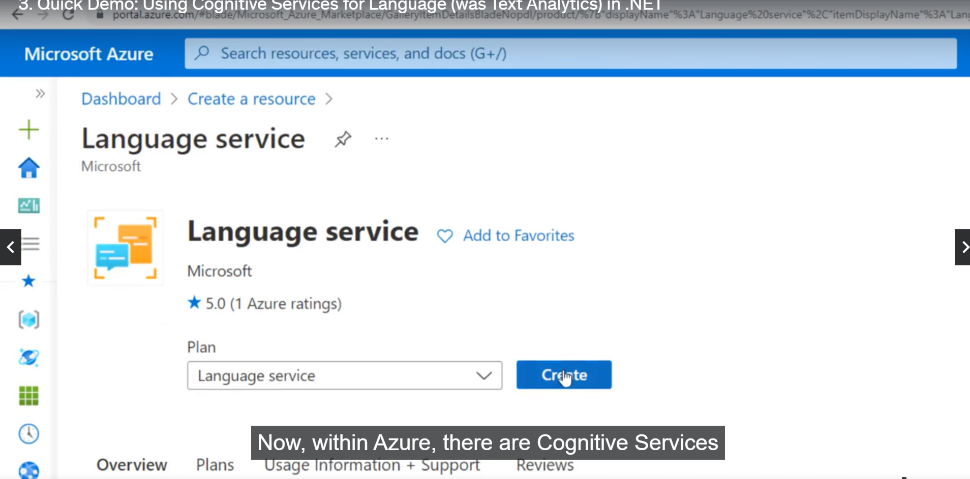

1. **Go to resource and copy Api key and endpoint to use it in code.**

1. **C# Console application**

**Console Output**

Python Source Code: <https://github.com/gottagetgit/AI102Files>

.NET Source Code: <https://github.com/Azure-Samples/cognitive-services-quickstart-code/>

**Suggested Resources for AI-102:**

Microsoft exam page - <https://docs.microsoft.com/en-us/learn/certifications/exams/ai-102>

Official Microsoft AI-102 code repository - <https://github.com/MicrosoftLearning/AI-102-AIEngineer>

**Samples in Other Languages:**

Cognitive Services C# Samples: <https://github.com/Azure-Samples/cognitive-services-dotnet-sdk-samples>

Cognitive Services Python Samples: <https://github.com/Azure-Samples/cognitive-services-python-sdk-samples>